**CTIS 255 – Final  
8 Jan 2022**Duration: 120 mins.

**Don’t forget to download “final.zip” file that contains required files (***jquery.min.js, q3.html, css and img folders***) and video files (***q1.mp4, q2.mp4, and q3.mp4***). The video files show what you are supposed to do.**

**Q1 (30Pts)** Write a dhtml program that shows “ONE” text at the middle of the page, font size is *50px*, and cursor over the text is *pointer,* Fig 1. When you click on the text, it shows the next number. If the number is “THREE”, it goes back to “ONE”. ***Watch q1.mp4.***

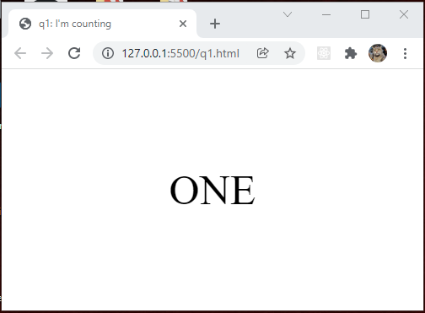

**Fig 1:** Initial Page

**Grading Policy:** CSS (*5Pts*), Click to show next number *(20Pts)*, Back to “ONE” (*5Pts*)

**Q2 (35Pts)** Write a dhtml program that shows a 3x3 table. The size of the cells is 60x60 pixels, and their borders are “1px solid #AAA”. The program selects a random cell at the beginning, and marks it as black background color, Fig 2. Once you click the black tile, it switches a random white cell with the black one. The cursor type on black tile is “pointer”. It also shows “+10 Pts” text at the position of click, and it animates. Initially, the font-size of the text is “14px”, its color is “blue”, it grows gradually up to “24px”, and it moves “100px” upward in 1 second. At the end of the animation, the text is removed from the page. ***Watch q2.mp4.***

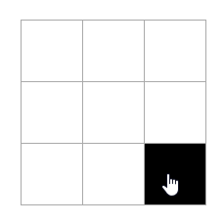  
**Fig 2:** Table and Form

**Grading Policy:** HTML, CSS (*5Pts*), Initial Random Cell (*10Pts*), Click to next random cell (*10Pts*), “+10 Pts” text animation (*10Pts*)

**Q3 (35Pts)** Write a shopping cart dhtml application that allows users to increase/decrease/remove the amount of a product in the shopping cart. You are given q3.html and its assets “./css/q3.css”, and images under “img” folder, Fig 3. You will NOT touch any of those files. I may use a different shopping cart in assessment. You are going to implement “**q3.js**” only. In the shaded area at the top, -CNT- will be replaced by the number of selected products by checkboxes, and -SUM- indicates the grand total of the shopping cart. Initially, by parsing HTML codes, you will calculate the grand total, and show the number of initially selected items. (In the assessment, there may be more than three products). “+”/”-“ button increases/decreases the amount by one respectively. If you click “-“ button when the amount is “1”, it deletes the product from the cart. ***Watch q3.mp4***.

***Hints:*** 1) “:checked” selector selects checked checkboxes, 2) jQuery object has “length” property, it stores number of selected elements, for instance, $(“p”).length returns number of selected paragraphs 3) to process selected elements, use “each()” method. To move around one element, use parent(), next(), find() etc.

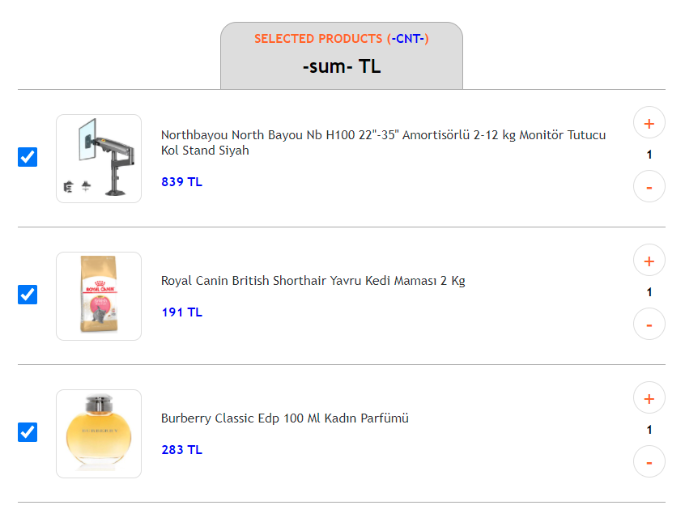  
**Fig 3:** Given shopping cart page

**Grading Policy:** Initial grand total (*5Pts)*, Initially selected products *(5Pts)*, “+”/”-“ updates amount by one (5Pts), “+“/”-“ updates product price *(5Pts),* “-“ deletes product *(5Pts),* Calculate grand total dynamically (5Pts), Show selected products dynamically (5Pts)

**Attention:**

* Submit ***name_surname.zip***
* You are free to use any printed materials during the exam.
* USB devices are strictly forbidden during the exam.
* You will use **jQuery** for the questions. If you use DOM API, you’ll get half of the grades.

GOOD LUCK